

**ANSWERS**

Year 11 ATAR Human Biology

Task 1 – Carrot Osmosis

Investigation and Validation

Weighting: 10%

Validation

Name: __________________________________________________________

Form: _____________________________

Investigation Report: Validation: Total Mark:

/ 38 / 39 / 77

**Please complete the following questions in full sentence answers using your knowledge from the Carrot Osmosis Investigation.**

1. The following question is in relation to the carrot osmosis report you have constructed and information which you have gathered.

a) Describe how saltwater affects osmosis. (2 marks)

**Carrot becomes hypertonic (1) with high solute and net movement water outside cell cause shrink (1).**

b) In hospitals saline solutions are typically used to help patients with dehydration, where the solutions range up to 0.9% of NaCl. Discuss why saline solutions are used compared to water saline? (2 marks)

**Saline solution allows isotonic movement (1), allow cells to repair with regulated net movement without swelling or shrinking hyper/hypotonic (1).**

1. The membrane surrounding cells is described to be semipermeable.
2. State what the term **semipermeable** means in terms of transport.

(1 mark)

**Only allows certain substances in and out of cell (1).**

1. State what type of bilayer the cell membrane is. (1 mark)

**Phospholipid bilayer (1) (no marks for mentioning half of correct answer)**

1. Outline the **structure** of the hydrophobic and hydrophilic components of this bilayer. (2 marks)

**Hydrophilic heads on outside (1)**

**Hydrophobic tails in inside (1)**

1. Describe the **function** of the hydrophobic and hydrophilic components of this bilayer. (2 marks)

**Hydrophilic water loving and polar (1).**

**Hydrophobic water hating and non polar (1).**

1. During the investigation, you would have observed the transport of water across the cell membrane of the carrot described as **osmosis**.
2. State whether or not this type of transport is **active** or **passive** and explain why in terms of concentration gradient. (2 marks)

**Passive (1) due to water travelling from high to low concentration (1).**

1. Describe an example where osmosis may occur in the digestive system. (2 marks)

**Any reasonable explanation outlining organ and water conc., for example:**

**Water absorption in large intestine (1) from high concentration in undigested food to low concentration in body absorption (1).**

1. Outline the differences between a **hypertonic** and **hypotonic** cell, and identify which of the two the saltwater carrot adhered to. (3 marks)

**Hypertonic lower concentration of substance and cell shrinking (1)**

**Hypotonic higher concentration of substance and cell growing (1)**

**Saltwater carrot hypertonic (1)**

1. Whilst osmosis is a form of diffusion, it does not classify under the category of **active transport**.
2. Identify the 2 types of **vesicular transport**. (2 marks)

**Endocytosis (1)**

**Exocytosis (1)**

1. Active transport requires the presence of energy, state the form of energy used in this transport. (1 mark)

**Adenosine triphosphate/ATP (1)**

1. State an example where **pinocytosis** and **phagocytosis** may occur in the human body. (2 marks)

**Any relevant example identified for pinocytosis (1) and phagocytosis (1).**

**Eg. Pinocytosis of dissolved liquid lipids entering villi wall in small intestine (1)**

**Eg. Phagocytosis immune cell macrophage ingesting bacteria cell (1).**

1. **Carrier mediated** is one form of transport that may be classified as both active or passive.
   1. Outline what type of carrier mediated transport is **passive**.

(1 mark)

**Facilitated diffusion (1).**

* 1. Explain the role of **proteins** in the cell membrane of carrier mediated transport. (2 marks)

**Carrier protein binds to molecules wanting to pass through channel (1)**

**Carrier protein changes shape in order to move molecule from one side of the membrane across to the other side (1).**

* 1. Discuss what causes carriers to become **saturated.** (2 marks)

**All available carriers occupied/used will become saturated (1) causing an increase in concentration of molecules transported (1).**

* 1. Transport of glucose is typically done via carrier mediated transport, explain why glucose cannot be transported via simple diffusion. (2 marks)

**Glucose molecule too large (1) and hydrophilic therefore requiring protein channel to pass through membrane (1).**

1. The graph below shows the rate of uptake of two solutes via different forms of transport.

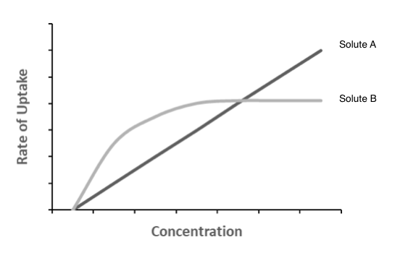

* 1. State which type of transport is represented by each solute and provide an example of two materials moved by each method.

(6 marks)

**Solute A Diffusion (1)**

**Any of the following 2 examples (1 mark each = max of 2 marks)**

**Water, oxygen, carbon dioxide, fatty acids, steroids, ions, drugs.**

**Solute B Facilitated Diffusion/Carrier Mediated Diffusion (1)**

**Example of glucose (1) and amino acids (1).**

* 1. Describe 4 potential chemical and/or physical differences of Solute A and Solute B in relation to their movement across the cell membrane. (4 marks)

**Any of the following answers (1 mark each = max of 4 marks)**

* **Smaller size particle go through diffusion quicker**
* **Larger size particle diffuse slower/require facilitation**
* **Polar/hydrophilic particles require facilitation/diffuse slower**
* **Non polar/hydrophobic particles go through diffusion quicker**
* **Lipid soluble particles undergo diffusion quicker**
* **Water soluble particles require facilitation/diffuse slower**